**Grow Your Instagram**

**Choosing a niche:**

* Use capital letters while choosing a name for your page
* Use emojis in your bio that fit with it but don’t overdo it
* Have a good aesthetic for your page e.g. consistent color scheme, handful of fonts, clear writing style, unique video format, and a recognizable logo
* Profile pic should match your page logo, aesthetic etc.
* Icon based logo > text-based logo (Preferred)
* If you are using slides for your posts, 1st slide should be what your post is about, nice picture, attention grabbing etc. 2nd to 9th should contain the information you want to provide to the user. 10th slide should be about like, comment, follow, or call to action etc
* Reels can possibly get you way more views than normal even from the people that don’t follow you
* Reels are preferred to be videos/images with voice/no voice and not just text-based
* In order to be engaging, go viral and grow your page, your reels should accomplish the following:

1. Your reels should grab the attention of your audience e.g. “THIS BURGER WILL MAKE YOUR BULK 10 TIMES EASIER!” or “THIS DELICIOUS BURGER HAS 3X MORE PROTEIN THAN YOUR PROTEIN SHAKE”
2. Your reels should provide valuable information in a digestible and entertaining format (so that your audience will engage with them and make them go viral) (video should **preferably** be 30s or less)
3. Your reels should turn as many new viewers into followers as possible e.g. ask viewers to like, share, and comment in the last few seconds, also use animated stickers and buttons to help you with it

* If you were to post 9 stories a day, you could split them up as follows:

1. Poll
2. Quiz
3. Interesting tips or fact about the stuff you talk about
4. Meme
5. Advert
6. Lifestyle story
7. Repost of old post or new post you just uploaded
8. Lifestyle story
9. Advert

* 2 posts or reels per day is recommended
* To get the best time to post, you should figure out, from where, most of your audience is

**Grow your page:**

* Three main ways you should be focused on to grow your page to get high quality followers:
  + Organic Growth
  + Promotional Growth
  + Giveaways
* Ideally, you want to be paying around 1 dollar for every 1k followers they have if you are asking for a promo in their stories, and twice as much if you are asking for a promo in the form of a feed post or reel
* Best way to do a giveaway is to partner with a brand or creator in your niche
* **NOTE: Always include a disclaimer stating that Instagram is not affiliated with the giveaway in both the post and the post description. Otherwise, Instagram may take down the post.**
* Tag your loyal fans in your stories/reels/posts
* You can hire a ghostwriter/write yourself an e-book which you can sell to your followers for 10$ to 20$ or more. For those who don’t read, you can convert it into audiobook and sell it for about 15$ to 25$ or more
* You can even make and sell courses for about 50$ to 300$ or more depending on the value they provide
* You can also sell your services to people but it has one downside i.e. that you need to devote more time compared to the time you needed to devote for selling e-book/audio-book/courses. However, the upside is that it is more satisfying (helping someone 1 on 1). Also, you can increase the price as your reputation increases and become better
* You can sell your products/services etc on a video call with your clients (could be paid)
* You can also hold webinars paid/free where you can provide more value and tell the people about your services/courses etc
* Coming up with a subscription service is the best way to get a continuous stream of income since it is recurring
* Affiliate marketing is also a great way to make money since it doesn’t require you to make products and you can do it based on niche of your page. Do some research and find the reputable companies in your niche that offer good commission rates
* When your following becomes good enough, you can reach out famous brands for affiliation but make sure to not post about them too much as you don’t want your followers to think that you have become an advertising agency

**Protecting your page:**

* You should do everything in your power to make sure your content abide by Instagram’s community guidelines since, if you offend them, they may take it down with no proper explanation
* This means you should not insult people in the comments under your or someone else’s posts, you should not insult people in your DMs, you should not post offensive comments or memes, you should refrain from expressing right-wing political opinions, you should never defend conspiracy theories and you should never mention COVID or Vaccines
* Do have back-up account in case shit goes down, and tell your followers about it for 1-2 times a week. You should have at least 1/3 as many followers as the main page
* Having other platforms also help a lot since it can potentially help you get saved from censorship. Telegram channel and an email list are great ways to protect your business from censorship
* The best way to grow a Telegram and/or an email list is to offer something free in exchange for people’s emails. This freebie tends to be a short booklet in which you discuss a specific aspect of your content very briefly.
* For example, “3 KETO RECIPES YOU WON’T FIND ANYWHERE ELSE”, “THE BEST INVESTMENT WATCHES!”, “5 EXERCISES TO MAKE YOUR ABS POP”, etc
* Do make friends in similar niche since it can potentially help you when you get banned because they will shout you out in case you get banned

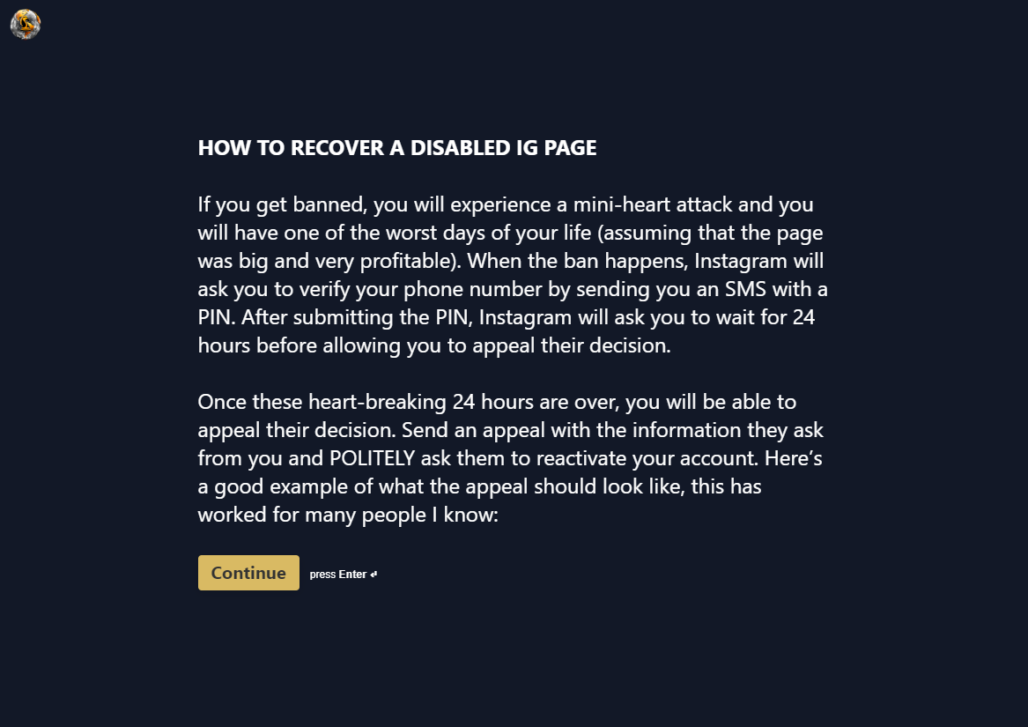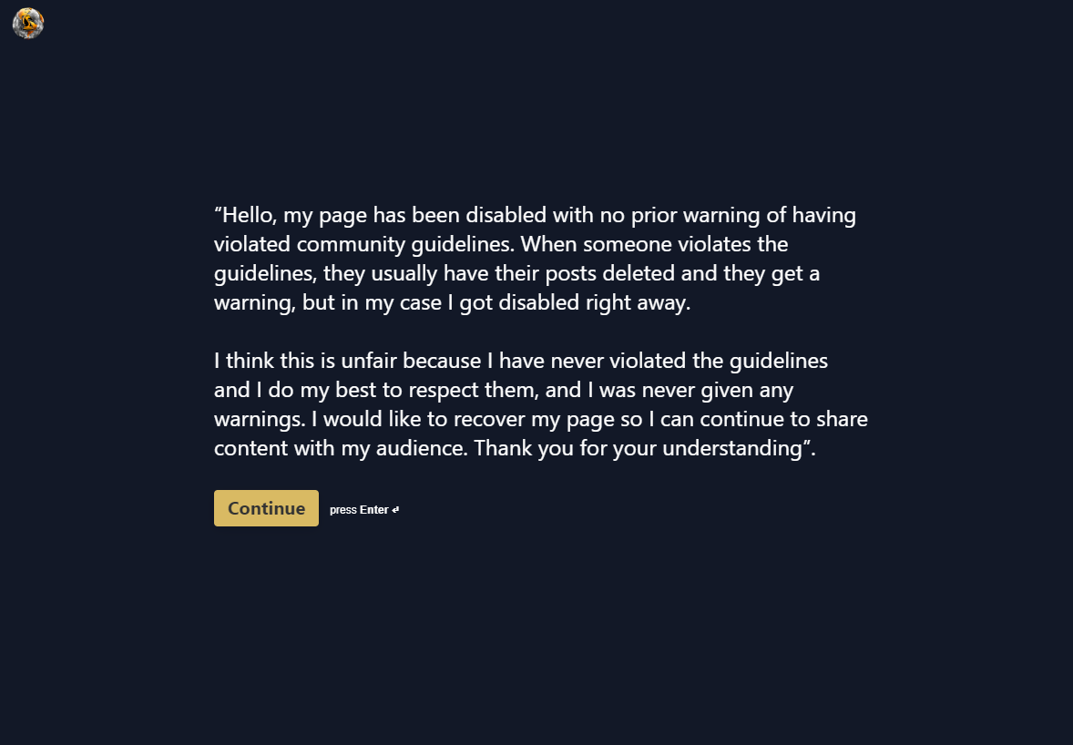

* If your page has not been restored within 12 hours, try again. Try up to 5 times over the next few days. If nothing works, send an
* appeal through the following links and follow the instructions there:
* <https://help.instagram.com/contact/1652567838289083>
* <https://www.facebook.com/help/instagram/contact/606967319425038>
* <https://help.instagram.com/contact/396169787183059>
* If none of these links work after multiple attempts, chances are you won’t be getting the page back. Not all hope is lost, though, some people completely give up and forget their old pages, only to send an appeal again 3 months later and get their page almost immediately